Date: / /2025

Lab Practical #02:
Install Figma on a local machine and understand the Figma software IDE.

Practical Assignment #02:
Install Figma on a local machine and understand the Figma software IDE. Complete the 'Figma Onboarding Scavenger Hunt.' Take screenshots of the important tool sections and add it here. Describe each component.
After installing, open a new file and:
- Find: The 'Frame' tool and create an 'iPhone 14' frame.
- Create: A perfect 50x50px circle and a 200px-wide text box.
- Style: Make the circle red and the text 'Hello World' in 24pt 'Inter' font.
- Explore: Open the 'Community' tab, find one 'Icon Set', and duplicate it into your file.

Description:

Install Figma & Understand the IDE
  - Installation
    - Go to the Website: Open your browser and go to www.figma.com.
    - Sign Up/Log In: Create a free account or log in if you already have one.
    - Get the App: While Figma works entirely in the browser, the desktop app is recommended. On the main dashboard after logging in, find the "Downloads" section or look for a download link at the top of your account settings.
    - Download & Install: Download the installer for your operating system (Windows or macOS) and run it.
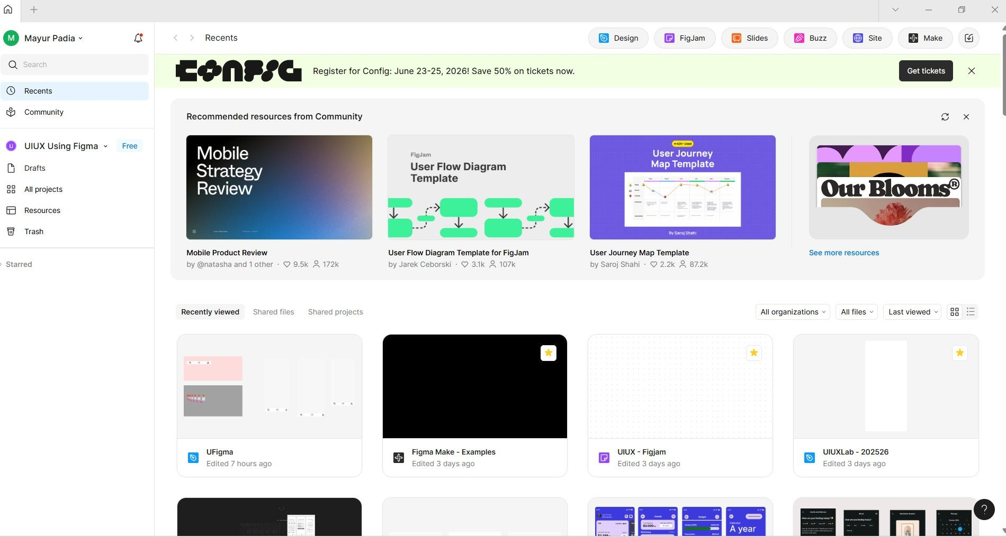

Date: / /2025

Understanding the IDE (Your "Tool Screenshots")
Once you open a new design file, the interface is broken into a few key areas. Here is a description of each, just as you would annotate on a screenshot:

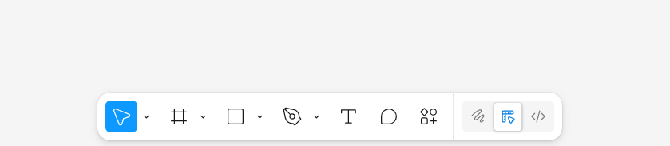
Top Toolbar (The "Tools"):
      - Main Menu (Figma Icon): Accesses file options, preferences, and plugins.
      - Move/Scale Tools (V, K): Your main pointer for selecting and moving (Move) or resizing (Scale) objects.
      - Frame/Slice Tools (F, S): The Frame tool (F) is fundamental. It's the container for all your designs (like an artboard).
      - Shape Tools (R, O, L): A dropdown menu (defaulting to Rectangle) where you find Rectangle (R), Ellipse (O), Line (L), Arrow, Polygon, and Star.
      - Pen/Pencil Tools (P, Shift+P): The Pen tool (P) is for creating custom vector shapes and paths.
      - Text Tool (T): Used to create all text.
      - Comment Tool (C): Allows you to leave feedback comments directly on the design.

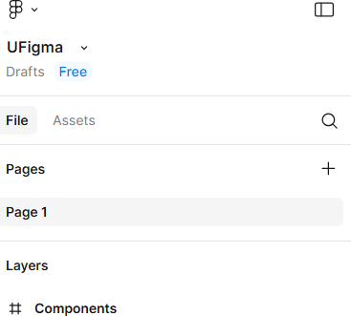
    - Left Panel (The "Navigator"):

Date: / /2025
      - Layers: This tab shows every single object (frame, group, shape, text) on your canvas in a hierarchy. You can reorder, group, and rename items here.
      - Assets: Once you create "Components" (reusable design elements), they live here.
      - Pages: You can have multiple pages within one file, which is useful for organizing different sections of a project.

Right Panel (The "Inspector" or "Properties"):

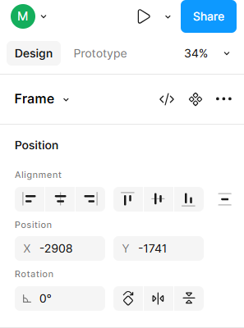 | 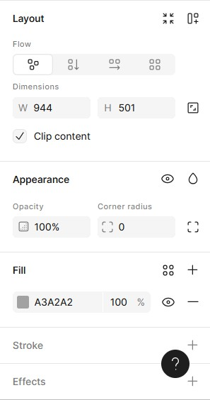

      - Design: This is the most-used tab. When you select an object, this panel shows all its properties: Alignment, Position (X, Y), Size (W, H), Fill (color), Stroke (border), Effects (shadows), and Text properties (font, size, weight).
      - Prototype: This is where you link frames together to create interactive, clickable prototypes.

Date: / /2025
      - Inspect: This tab shows developers the code snippets (CSS, Swift, XML) for any selected object, making handoff easier.

The Canvas (The "Middle"):
      - This is your main, infinite workspace where you place all your frames and objects.

Figma Scavenger Hunt: Step-by-Step
After installing and opening a new "Design File," follow these steps on your canvas:
- Create: A perfect 50x50px circle and a 200px-wide text box.
- Style: Make the circle red and the text 'Hello World' in 24pt 'Inter' font.
- Explore: Open the 'Community' tab, find one 'Icon Set', and duplicate it.
